Activities Dashboard Guide

This guide has been made to help society committee members use the Activities Dashboard. This is the new system for societies to book the SU Lounge for their events. It has been introduced so that all the necessary information and actions can be done in one place.
It is important that you submit your events as early as possible, even if you don’t have all the information confirmed yet. You are able to amend and update your event as you go and it should be seen as an ongoing process.
All events that take place within the SU Lounge must be submitted on the Activities Dashboard.

Deadlines:

The forms on the Activities Dashboard will note the specific date they are due.
2 weeks before the event | 1 week before the event
Guest speaker form | Risk Assessment form
 | Room booking form
 | Equipment loan form
 | Online Lounge Induction

Room Bookings
All event locations need to be logged on the Activities Dashboard. This is inclusive of both events taking place within and outside of the University Centre/SU Lounge.

Within the University Centre/SU Lounge

You can make a room booking for the SU Lounge using the Room Booking form on the Activites Dashboard.
Please note that submission of this form does not guarantee confirmation of the booking. Please wait until this form has been approved on the Activities Dashboard and you have received confirmation from the SU.

Outside of the University Centre/SU Lounge

Some events are best placed outside of the University Centre. In this situation, you may have researched and found an event location yourself. If so, you can log this location on the Room Booking form on the Activities Dashboard. Alternatively, you may be unsure where your event is best to be based and would like some additional support from the Activities Team. Should you need to you can set up a meeting with the Events Coordinator or an available Activities Team staff member, so that a location can be found and booked together.

Lounge Induction
To confirm your SU Lounge booking, you must complete the Lounge Induction, which covers the health and safety requirements for running your event safely.

What is Covered?

- Emergency Procedures
- Accident Reporting
- Lounge Rules
- Key Contacts
At the end of the Induction, you will be required to answer some questions based on what you learned.

Who Has to Complete this?

The Event Organiser is responsible for completing the Lounge Induction and is expected to attend and run the event. Any committee member can access the event and its forms, so the person who logs the event does not need to complete all forms.
If the Event Organiser or the person who completed the Lounge Induction can no longer attend, another attendee must complete the Lounge Induction before the event.

How do I complete the Lounge Induction?
The Lounge Induction can be found on the Activities Dashboard as a tab at the top of your screen when you are editing your event.

If you are unable to see this tab on your Dashboard, you will need to add the form by clicking the “+Add Form” button and selecting ‘Lounge Induction’. This should bring the Lounge Induction into your Forms list, where you can see the status of the form.

Equipment Loans
Whether or not your event is hosted in the SU Lounge, you can request to borrow equipment provided by the SU.

What Equipment is there for societies?

Fixed to within the SU Lounge | Able to be used for non-Lounge events
- TV with HDMI  - Speaker  - Karaoke Machine | - Projector  - High Visibility Jackets  - Megaphones

How Do I Request an Equipment Loan?

You can request any equipment you need via the Equipment Loan form on the Activities Dashboard. This form is optional, so you may need to add it using the “+ Add Form” button on your activity overview page.

Risk Assessments
Every event that we run needs to be risk-assessed. This is not just a tick box exercise, but it's a great way to think through an event and create a plan to deal with a variety of situations.
As the event organiser, you are responsible for reviewing the SU Lounge risk assessment and submitting an additional risk assessment for any activities not currently covered. Once complete, the Activities Team will sign off on the risk assessment via the Activities Dashboard.

What to consider when filling in a risk assessment

Here are a few suggestions on some areas to consider when filling out a risk assessment. This list is not exhaustive and individual events will have unique risks associated with it so make sure to dedicate enough time to thinking through every aspect of your event. It is also helpful and recommended to consult with others when doing a risk assessment as different people notice different risks.
- Slips, trips and falls.
- Crowd control.
- Fire emergencies.
- Medical emergencies.
- Food concerns - i.e. dietaries or allergies.
- Accessibility of venue or platform.
- Publicity or public reception to events.
- Physical assets - e.g. technical equipment.
- Travel considerations.
- Reputational risks.

How to Assess Risk Level

In every risk assessment, you will be asked to assess the risk level of the activity before and after you have implemented the mitigation measures. This clearly showcases how the addition of the mitigation measures makes the activity safer.
To assist with risk level assessment, we have a risk matrix attached to every risk assessment template. This provides an objective measure of risk level to guide event leads. For clarity you are assessing the level of risk before and after the mitigation or control measures have been implemented.

Risk Matrix:
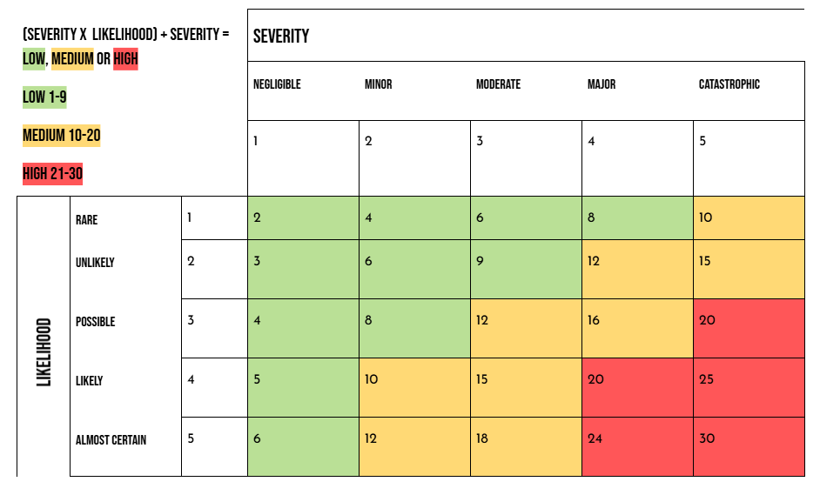
Likelihood:
Rare - has never happened (remote possibility, could occur)
Unlikely - has happened in the past or may happen in the next 10 years (not expected)
Possible - has happened in the past or likely to happen in the next 1-5 years (not surprised if happened)
Likely - has happened in the past or likely to happen in the next year
Almost certain - is expected to happen

Severity:
Negligible - barely noticeable (may not even be notified)
Minor - minor injury or discomfort (no treatment required)
Moderate - severe injury or incident (first aid treatment required/A&E or immediate action required)
Major - major injury or incident (hospital admission and treatment needed or all hands on deck response involving trustees)
Fatal - results in death or catastrophic consequences for the society/club

Low, Medium or High
There is more of a weight on the severity of the risk therefore, the calculation of the overall risk level is (Severity x Likelihood) + Severity.
Low (1-9) - the likelihood of the risk/hazard occurring and its impact severity is low therefore the risk/hazard is accepted and no further action is required.
Medium (10-20) - the likelihood of the risk/hazard occurring is increased and the impact severity could cause harm and therefore is of Medium risk. The risk/hazard will be monitored with frequent assessments carried out to ensure that the risk/hazard does not increase.
High (21-30) - the likelihood of the risk/hazards occurring is likely and the impact severity could cause significant or long-term harm and therefore is High risk. The risk/hazard should be treated, with the implementation of actions to reduce the severity of impact or likelihood of occurrence.
Example:

List the significant hazards | Describe what could go wrong | BEFORE CONTROL:Is the risk high, medium, or low? | List the control measures to be put in place | AFTER CONTROL:s the risk high, medium, or low? | Any further actions which may be beneficial
EXAMPLE: Obstructions or other trip hazards | EXAMPLE:  Attendees or Staff could fall due to an obstruction in the event space. | EXAMPLE:  Medium  Calculation:  (3x4) + 3 = 16 | EXAMPLE:  Staff will be on hand to remove trip hazards should they arise.  Walkways and doorways will be kept clear from obstructions and monitored throughout the event. | EXAMPLE:  Low  Calculation:  (2x3) + 2 = 8 | EXAMPLE:  Staff members will be positioned near stairs to ensure people are acting safely.

Mitigation Measures/Risk Controls

All parts of a risk assessment are important, but the mitigations you put in place to control the risk level are an important aspect of the risk assessment as this is the part where you outline WHAT you are going to do to ensure the activities of the event are safe.
Like all the other aspects of risk assessment, mitigation measures involve a certain level of subjectivity, meaning there is no one ‘correct’ mitigation measure for any one risk. Therefore, working with someone else, to at least bounce ideas off of, is really helpful when coming up with the ways in which you will control risk levels of particular activities.

If your society requires additional support in this area, please contact the Activities Team at activities@cambridgesu.co.uk in plenty of time.

Guest Speaker Policy
If you want to have a guest speaker at your event, you will need to submit a Guest Speaker Form. This is because the Activities Team needs to fully understand who is being invited and any information associated with them to ensure the event is safe and compliant.

Multiple Guest Speakers

If you are hosting an event with multiple speakers, such as a panel or conference, you will need to submit a guest speaker form for each guest speaker.
You can do this by adding a new form on the Activities Dashboard and choosing Guest Speaker Form.

Deadlines

Guest Speaker Forms MUST be submitted at least 2 weeks prior to the event taking place. This is because the Activities Team has to complete research on each guest speaker to assess the risk associated with them. More often than not, this will be completed within 1 week of the form being submitted. Guest speakers cannot be officially invited or publicised until the guest speaker form/s have been approved on the Activities Dashboard, so the earlier you submit the form(s) the better.

Guest Speaker Risk

Should the Activities Team’s research reveal that the guest speaker/s presents a medium or high risk, we will ask the event lead to adapt the risk assessment to incorporate mitigation measures to control this risk.
A medium or high-risk guest speaker/s does not automatically mean they are unable to speak at the event; however, failure to engage in the mitigation process may result in them being unable to attend.
Below are some of the risks we have to take into consideration when assessing a speaker:
- Anything that might affect student wellbeing, health and safety.
- Reputational risk (for you, the University of Cambridge, Cambridge SU and our clubs or societies).
- The history of the speaker and any media attention they have received previously.
- Potentially controversial subject matter.
- The reputation and potential motivations of any sponsor or partner agency.
- UK law including those regarding discrimination, incitement and intimidation.
- Ensuring that we are not perceived to be or are actually providing a platform for illegal activity.
- Ensuring that the event can be carried out in a way which is in line with our charitable objectives and benefits students as students.
- The potential for the speaker’s presence on campus to give rise to a breach of the peace.
- The potential to breach the University’s Code of Practice on Freedom of Speech or limit any students, staff or public’s right to legal free speech on campus.

